SYSTEMS ANALYSIS AND DESIGN
Student’s name
Institution name
Instructor’s name
Course title
Date

Context Diagram
This particular report structure has been associated with the relevant system structure developing the required student enrollment system for ABC University under specific consideration. The applied analysis has been thoroughly structured in this diagram provided below.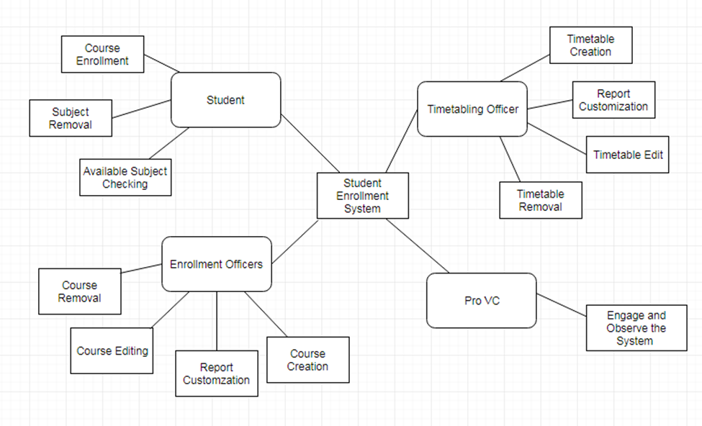

Figure 1: Context Diagram
The detailed assessment of the relevant student enrollment and system feature has been associated with the structure of the relevant system for operative management of necessary structural; approach for implied processing of the design and development of specific management systems for online student enrollment operations Benveniste et al. (2018). The associative system's structure has been used to operate and validate the necessary relevance of structural development of required reforms under specific consideration for the implemented analysis and processing of structural development of operation presented here.
The systematic procedure is initiated with the necessary aspect of Student as a specific user under consideration. The student has managed the necessary structure of analysis to register onto the structure of the specific system and apply for the relevant structure of association for the necessary development of management operations for the selection of courses and the application for specific subjects that are required to be provided with the specific choice of course. This procedure can be done through the specific checking of the available subject under consideration. The student is responsible for initiating the relevant reforms for systems processing.
The specific Enrollment officer is associated with the proper requirement processing for the specific management systems structure for developmental analysis and creating specific courses for the students to view and enroll. Bortolini et al. (2017) have mentioned that the same also manage the specific courses created by the enrollment officer. The respective systems feature associated with the processing of relevant systems through applied concepts of management for removal of course and editing, according to the specific need. The relevant system's structure is also required to be validated by analyzing management operations through the structural development of providing a customized report.
The specific Timetabling officer is associated with the proper requirement processing for the specific management systems structure for developmental analysis and creating specific timetables for the other stakeholders to view. The same also manage the specific courses that can be created by the enrollment officer. The respective systems feature associated with the processing of relevant systems through applied management concepts to remove timetable and edit timetable according to the specific need. The relevant system's structure is also required to be validated by analyzing management operations through the structural development of providing a customized report.
Pro-Vice-Chancellor is solely associated with the proper observation and maintenance of the specific operating system structure for the Online Student Enrollment System of ABC University. The apparent systems have to be managed through the necessary development of specific reforms for the apparent observation and management of the proper structure of development.
Level-0 DFD
The applied concept of the relevant context diagram has been validated for the specific creation of a proper Level 0-DFD for the specific structural association and development of certain procedures related to the proper management of systems through applied concepts of appropriation. The necessary relevance to the structural management of the specific application systems associate with the proper reforms through the processing of the entire structure of relevance of data flow processes. 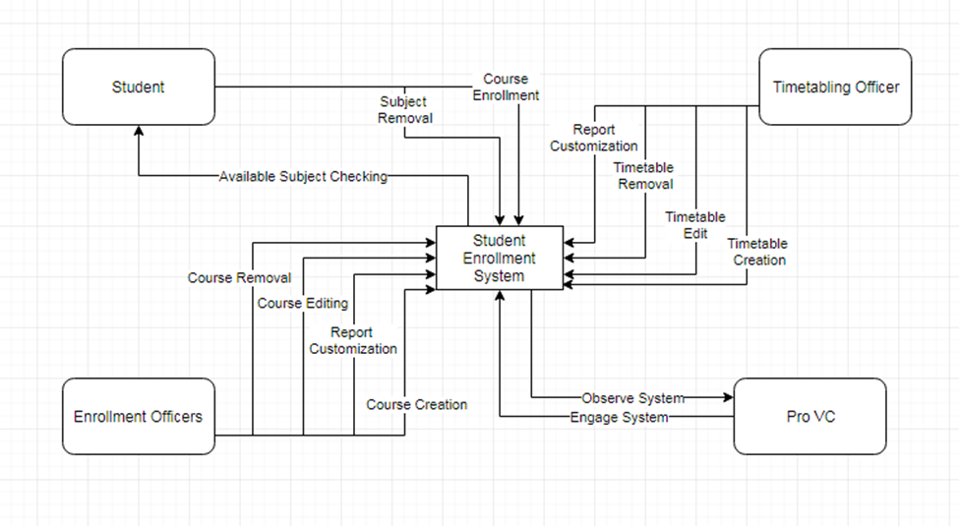
Figure 2: Level-0 Data Flow Diagram
The Level 0 data flow has been associated with the proper management structure through the necessary application of management concepts. The implemented association has been with the proper structure of the application. According to ElMaraghy et al. (2017), the applied concept of reference has been associated with the proper developmental reforms through structural development of assessed systematic reforms for procedural approach through structural development of the data flow's specific management systems structure. Here the specific task of operation for both timetabling ad enrollment officers has been associated with the procedural association of unit-directional flow of data for the systematic procedure through developmental analysis. The student, however, has a bi-directional systems association.
The applied system's structure has been validated by managing reforms for the structural application of associative management through course specification and management reforms. (Friedman & Yoo, 2017). Here, the development aspect has been managed through the structural association of relevant strategic management of various sources of operation through applied developmental reforms. The necessary management association structure with this initial level data flow has been appropriated through strategic management of specific validations.
The relevant use of systematic observation related to the Pro VC under consideration is one of the most important aspects of data flow through management reforms' structural development. Friedman, Hendry & Borning (2017) have stated that the respective management has been associated with the proper relevance to operative management's septic management structure. The applied concept of association is totally bi-directional for operative management and maintenance. The associative development has been managed through the necessary development and applied analysis of application through structural development of management reforms. The specified system has been analyzed through proper justification.
Inter Relation: The specific Pro VC associates with the respective operation procedure for the management systems structure of the applicable scenario. As mentioned in the specific research (Göhler, Ebro & Howard, 2018), the entire operatives manipulate these courses and the subjects. The respective systems inter relation associates with the procedural processing of relevant management operations through structural development of the proper management associations through strategic planning of the specific applications. The necessary development has been associated with the procedural aspect of management reforms by associating with management aspects through Timetabling officer and Enrollment Officer.
Level-1 DFD of non-trivial processes
This particular discussion has been associated with the structural management of systems through the apparent development of an advanced level of data flow for the respective non-trivial procedure of approach within this particular system's structure under appropriate management. Applied developmental structure of association initiates with the management systems through the Enrollment process under consideration.
Enrollment Process
The enrollment procedure under consideration has been associated with the procedural application of level 1 data flow for Student Enrollment through validation of specific courses under assessment. The structural development has been managed according to specific systems appropriation of the valid deliverables. 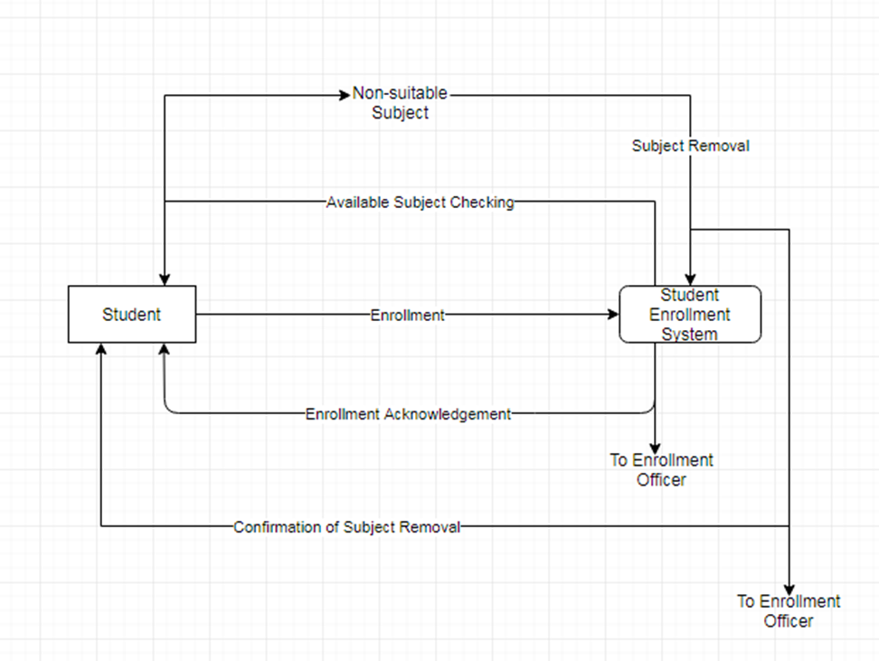

Figure 3: Level-1 DFD of the enrollment process
This level 1 data flow has been associated with the entire procedure developed with respective level 0 data flow for the student enrollment systems for ABC University. Maier et al. (2018) have stated that the systems initiate with the specific operation of registration from the student side of the operation, an acknowledgment of registration is processed with the view of various courses, and the student can choose specific subjects to study if a certain subject is unsuitable, the student associate with the specific operation through applied structural reforms through the processing of subject removal. The systems then acknowledge this, and the student can then choose the specific course with a suitable subject option.
Course Process
The associated listing and management of specific courses have been associated with the relevance of structuring the appropriate management reforms for designing this level 1 data flow process (Mourtzis et al., 2018). This particular diagram presented below associates with the procedural aspect of implementing the entire enrollment officer process under the logical structure.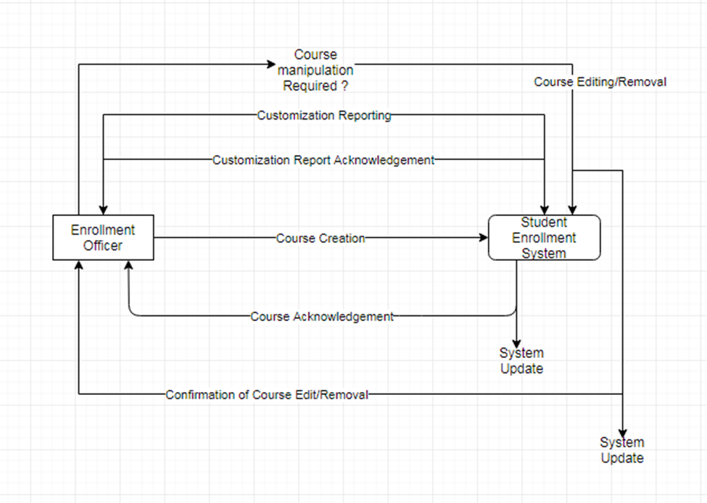

Figure 4: Level-1 DFD of course process
The specific diagram presented above associates with the system's structure for apparent scheduling of the specific enrollment officer duties through the structuring of applied courses for the association. The structure of management has been validated accordingly. According to Szczecinski, Hunt & Quinn (2017), course creation with acknowledgment helps the enrollment officer operate on specific courses with the procedural application of developing the relevance to the course edit, remove and update specifications accordingly requirement. The relevant application of strategic development then associates with the enrollment officer filling the report for customization to be viewed by all the stakeholders. An acknowledgment is received for the relevant operations.
Timetable Process
The associated listing and management of specific timetables have been associated with structuring the appropriate management reforms for designing this level 1 data flow process. This particular diagram presented below associates with the procedural aspect of implementing the entire timetabling officer process under the logical structure.

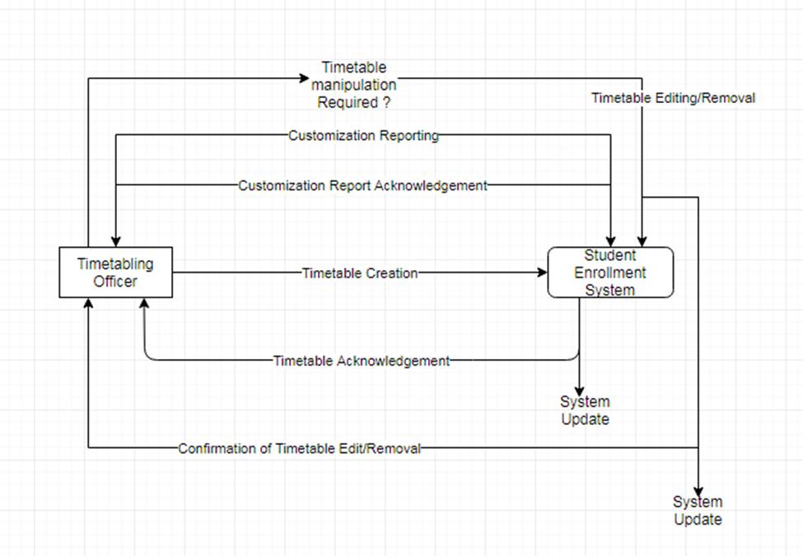
Figure 5: Level-1 DFD of timetable process
The specific diagram presented above associates with the system's structure for apparent scheduling of the specific timetabling officer duties through the structuring of applied timetables for the association. The structure of management has been validated accordingly. According to Sztipanovits et al. (2018), the process of timetable creation with acknowledgment helps the timetabling officer operate on specific courses with the procedural application of developing the relevance to the timetable edit, remove and update specifications according to requirement. The relevant application of strategic development then associates with the timetable officer filling the report for customization to be viewed by all the stakeholders. An acknowledgment is received for the relevant operations.
Entity Relationship
The respective entity-relationship is associated with the proper procedural approach of management and structural reforms through the applied structure of relevance to the strategic systems through database association for the respective Student Enrollment System procedure.
i) Identification of entities
Here the specific entities have been associated with the apparent management systems structure. The specific entities under consideration have been associated with the procedural approach of management of systems through structural processing of data through these entities and presented below:
- Account
- User
- Designation
- Course
- Student
● Enrollment
The associated structure of specific development is initiated with the respective management systems' procedural processing through the applied implementation of the developmental reforms through strategic management of proper relationship development among these specific entities under consideration.
ii) Relationship Diagram
The detailed entity-relationship diagram presented below associates with the procedural aspect of management and application through associated structural development of proper management systems reforms through strategic management of applicable analysis for procedural processing of the associative management of systems.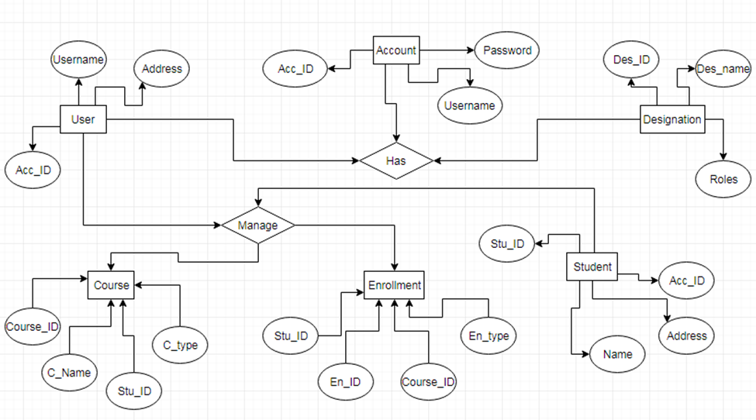
Figure 6: Entity Relationship Diagram
According to the management of specific identification and justification of entities, the initial association has to be processed through the strategic development of specific reforms for management scenarios under consideration. Here the account systems are associated with an Account ID for each of the stakeholders according to their specific operational needs.
The respective aspect of User and Designation has been structured or the apparent systematic developmental analysis and thorough management of the specific structure of accounts with development of specific privileged for the applied necessary application for the developmental analysis and management. The applied assessment has been structured for the relevant developmental reforms for various users' privileges according to their structure of operation within the system.
The specific entity of the student has been associated with the proper requirement of managing the specific account. According to Kazmin et al. (2017), this specific system associate with the level of operation associated with the Student ID, Name and Address of specific student for operative development.
The specified Enrollment and the Course association are entirely managed with the enrollment officer's help and administrative management of the timetabling officer. Persi et al. (2018) have mentioned that this specific association is developed for the entire database structural validation and relational association for the apparent management of specific data structure for the ABC University and operative management of structural development of the Student Enrollment System under specific consideration for valid appropriation.
Data Storage
The associative use of the physical database for these local systems' digital structure has to be managed and processed with the necessary developmental analysis and requirement for systems structure appropriation. Here, the necessary database needs to be managed through proper development of platforms for the applied database management through necessary structuring of the relevant systems for the apparent management through SQL Server and appropriate Management Studio applications.
The use of SQL Server Management Studio to associate and structure this particular database can help create proper administrative levels of database management systems through proper requirement analysis (Greiff et al., 2017). The specific table structured within the specific use of MySQL application would provide the proper structure of reference by using necessary primary and foreign key applications for the structural development of systems. The applied management scenario has to be operated through specific structuring and development of the specific systems by developing and analyzing specific relationships described in the entity-relationship structure presented above.
Relational Database Design
The proper class diagram structure has been associated with ERD modeling's necessary use under reference or associating through specific structural development.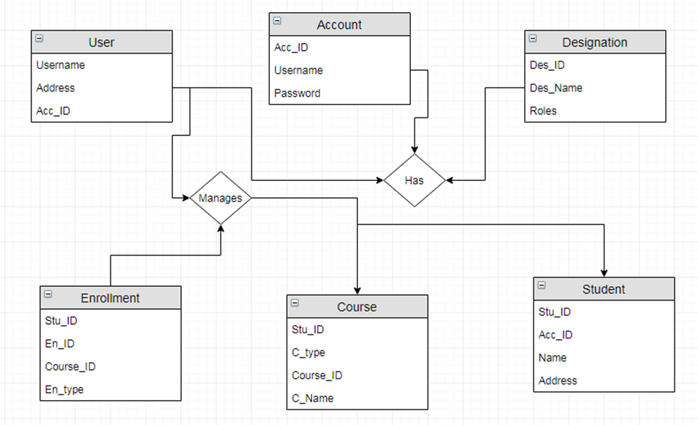
Figure 7: Relational Database Diagram
In this application system's structure, the apparent systems have been designed and developed through proper analysis and management reforms through structural development of class diagram logic with the proper establishment of relationship taken from the ERFD model developed previously (Computerscience.org, 2019). The proper structure of UML or Unified Modeling Language has been followed for the structural development of system features through the necessary analysis and application of specific management development.
The necessary structure has been developed to understand the exact physical database structure of validation properly. As influenced by Dennis, Wixom & Roth (2018), this particular design has been developed to properly associate specific primary and foreign keys for the database structure under consideration through the necessary development of specific management reforms through the structural association of developments. The proper management reforms have been structured by developing necessary systems application for the Student Enrollment System of ABC University for proper management structure of development and application.
References
Benveniste, A., Caillaud, B., Nickovic, D., Passerone, R., Raclet, J. B., Reinkemeier, P., ... & Larsen, K. G. (2018). Contracts for system design. Foundations and Trends® in Electronic Design Automation, 12(2-3), 124-400.
Bortolini, M., Ferrari, E., Gamberi, M., Pilati, F., & Faccio, M. (2017). Assembly system design in the Industry 4.0 era: a general framework. IFAC-PapersOnLine, 50(1), 5700-5705.
Computerscience.org, 2019. Systems Analyst. Retrieved from https://www.computerscience.org/careers/systems-analyst/ [25/10/2019]
Davis, W. S., & Yen, D. C. (2018). The information system consultant's handbook: Systems analysis and design. CRC press.
Dennis, A., Wixom, B. H., & Roth, R. M. (2018). Systems analysis and design. John wiley & sons.
ElMaraghy, H., Moussa, M., ElMaraghy, W., & Abbas, M. (2017). Integrated product/system design and planning for new product family in a changeable learning factory. Procedia Manufacturing, 9, 65-72.
Friedman, B., & Yoo, D. (2017, May). Pause: A multi-lifespan design mechanism. In Proceedings of the 2017 CHI Conference on Human Factors in Computing Systems (pp. 460-464). ACM.
Friedman, B., Hendry, D. G., & Borning, A. (2017). A survey of value sensitive design methods. Foundations and Trends® in Human–Computer Interaction, 11(2), 63-125.
Göhler, S. M., Ebro, M., & Howard, T. J. (2018). Mechanisms and coherences of robust design methodology: a robust design process proposal. Total Quality Management & Business Excellence, 29(3-4), 239-259.
Greiff, V., Menzel, U., Miho, E., Weber, C., Riedel, R., Cook, S., ... & Reddy, S. T. (2017). Systems analysis reveals high genetic and antigen-driven predetermination of antibody repertoires throughout B cell development. Cell reports, 19(7), 1467-1478. [Online] Retrieved from https://www.sciencedirect.com/science/article/pii/S221112471730565X [25/10/2019]
Kazmin, D., Nakaya, H. I., Lee, E. K., Johnson, M. J., Van Der Most, R., Van Den Berg, R. A., ... & Aderem, A. (2017). Systems analysis of protective immune responses to RTS, S malaria vaccination in humans. Proceedings of the National Academy of Sciences, 114(9), 2425-2430. [Online] Retrieved from https://www.pnas.org/content/114/9/2425.full [25/10/2019]
Maier, D., Heinrich, J., Zimmer, M., Maier, M., & Parspour, N. (2018). Contribution to the system design of contactless energy transfer systems. IEEE Transactions on Industry Applications, 55(1), 316-326.
Mourtzis, D., Vlachou, E., Zogopoulos, V., Gupta, R. K., Belkadi, F., Debbache, A., & Bernard, A. (2018). Customer feedback gathering and management tools for product-service system design. Procedia Cirp, 67, 577-582.
Persi, E., Duran-Frigola, M., Damaghi, M., Roush, W. R., Aloy, P., Cleveland, J. L., ... & Ruppin, E. (2018). Systems analysis of intracellular pH vulnerabilities for cancer therapy. Nature communications, 9(1), 2997. [Online] Retrieved from https://www.nature.com/articles/s41467-018-05261-x [25/10/2019]
Szczecinski, N. S., Hunt, A. J., & Quinn, R. D. (2017). Design process and tools for dynamic neuromechanical models and robot controllers. Biological cybernetics, 111(1), 105-127.
Sztipanovits, J., Bapty, T., Koutsoukos, X., Lattmann, Z., Neema, S., & Jackson, E. (2018). Model and tool integration platforms for cyber–physical system design. Proceedings of the IEEE, 106(9), 1501-1526.

